Marie Postma

Associate Professor in Cognitive Science and Artificial Intelligence

Tilburg University

The Netherlands

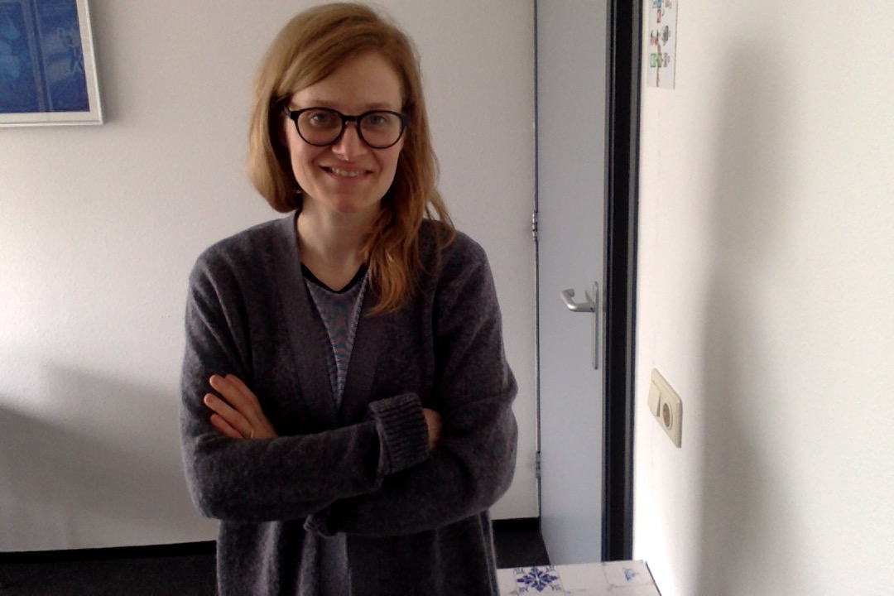

Marie Postma is Associate Professor in Cognitive Science and Artificial Intelligence at

Tilburg University in the Netherlands. In her work, she makes use of social signal processing methods, particularly speech processing and affective computing, to explore research questions pertaining to

human auditory perception and to domain-independent cognitive functions, such as inhibitory

control. The methodological approaches employed range from behavioral studies to

data mining and machine learning experiments. She has co-authored more than 50 papers and supervises several PhD students working in the area of serious gaming and virtual reality.

Title of the talk: Automatic detection of cognitive states